Colorado |  | Denver
Alaska |  | Juneau
Arizona |  | Phoenix
Hawaii |  | Honolulu
Kentucky |  | Frankfort
Wyoming |  | Cheyenne
Texas |  | Austin
Tennessee |  | Nashville
.5 |  | $$\frac{1}{2}$$
.25 |  | $$\frac{1}{4}$$
.75 |  | $$\frac{3}{4}$$
.333333 |  | $$\frac{1}{3}$$
.666666 |  | $$\frac{2}{3}$$
.3 |  | $$\frac{3}{10}$$
.2 |  | $$\frac{1}{5}$$
.8 |  | $$\frac{4}{5}$$
Bl |  | 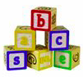
Cl
Gl |  | 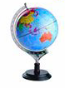
Fl |  | 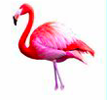
Sk |  | 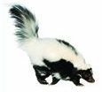
Tr |  | 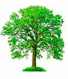
Sl
Sp |  | 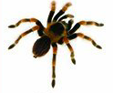
Sun |  | 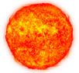  Center of  our Solar System
Mercury |  | 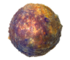  Closest to  the Sun
Venus |  | 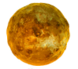  Named for the  Roman Goddess of Love
Earth |  | 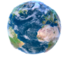  Only planet that  can sustain life.
Mars |  | 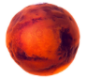  The Red Planet
Jupiter |  | 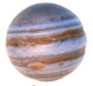  The Giant/Stormy  Planet
Saturn |  | 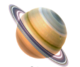  Known for its rings
Neptune |  | Coldest Planet & 8th Planet

