PROCEDURES FOR PROFESSIONAL


DEVELOPMENT WORKSHOPS

The University of Sioux Falls makes agreements with school districts or agencies to offer graduate workshop credit for educational experiences. Proposals, instructors’ vitas, and supporting documentation should be submitted at least three weeks in advance of the proposed workshop. An approval letter will follow.

THE FOLLOWING CONDITIONS APPLY:
- At least fifteen hours of instructional contact is required for one semester hour of academic credit.
- The Instructor of Record (the person who will be signing the grade sheet) must have a Master’s degree plus thirty additional hours of graduate work or documented exceptional expertise in the field of study.
- The cost of transcribing the workshop credit is $45 per hour.
- Participants who elect graduate credit for the workshops must hold a Baccalaureate degree.
- Graduate workshops at the University of Sioux Falls are offered on a PASS-NO CREDIT basis. The primary criteria for evaluation are attendance and active participation. Graduate workshop credits do apply for SD Teacher Certification renewal. USF recommends that you check with your school district and/or state licensing agency to verify these course offerings will meet your district and/or state requirements for salary advancement and/or state certificate re-licensure.
- If a workshop is submitted specifically for a letter grade, an assessment must be written into the syllabus prior to the workshop being submitted for credit. If the workshop is approved as a graded workshop, the grade roster should include grades only.

THE FOLLOWING PROCEDURES MUST BE FOLLOWED:
(Keep in mind that graduate and undergraduate workshops are handled separately, separate registrations, and separate grade sheets.)

PARTICIPANTS MUST:
- Register for the workshop at http://reach.usiouxfalls.edu with credit card or mail the registration form with check or cash to USF Workshops & Continuing Education, 1101 W 22nd St., Sioux Falls, SD 57105. More information on how to register will come with the approval letter.

INSTRUCTORS MUST:
- Complete the proposal form, syllabus and vita for each instructor and email to the Director of Workshops & Continuing Education at least three weeks prior to the start date.
- Inform the University if the workshop is cancelled.
- Instructor of Record will issue grades to USF at http://reach.usiouxfalls.edu within one week of the last day of the workshop. An instructor log-in and password will be emailed to the Instructor of Record upon approval of the workshop.
- Inform students that USF will not issue a grade report to each participant; however, they can log onto http://reach.usiouxfalls.edu to view their grade. Participants can request a transcript free of charge by downloading a transcript request form from www.usiouxfalls.edu.

Workshop Proposal Form
CONTACT INFORMATION
Agency making the request: |  |  | Transform Your Classroom
Contact Person submitting this proposal: |  |  |  |  | Lindsey Brewer & Lori Keleher
Street Address | 37386 208th St.
City, State, Zip: | Wessington SD 57384
Phone: | 605-354-4579 |  |  |  |  | E-mail: | transform@venturecomm.net

WORKSHOP INFORMATION
Title of proposed workshop: (Maximum of 4 words): |  |  |  | What School Could Be
Workshop has been approved in the past: |  |  |  |  |  |  | Yes |  | x |  | No
Target audience: | K-12 educators |  |  |  |  | Type of workshop (face-to-face, on-line, hybrid, etc.) |  |  |  |  |  |  |  | online
Check One (workshop will be P/NC unless you specifically request it be graded): |  |  |  |  |  |  |  |  | P/NC: |  |  |  | Graded: |  | x
Proposed Meeting Dates: |  | ongoing |  |  | Proposed Ending Date:  (Be specific – date all student work will be due) |  |  |  |  |  |  |  |  |  | ongoing
Registration Deadline: |  | ongoing
Course registration: |  | x | Open to public |  |  |  |  |  |  | Site based (available to select group only)
Number of hours of credit: (One credit requires 15 contact hours) |  |  |  |  |  |  |  | 1

TYPE OF CREDIT
Graduate Credit: | x | Undergraduate Credit:
Anticipated enrollment wanting credit for graduate credit: |  |  |  | 100 |  | For undergraduate credit:

INSTRUCTOR(S) INFORMATION
Primary Instructor’s Name: |  | Lindsey Brewer
Address: |  | 37386 208th St. Wessington SD
Additional Instructor(s) |  | Lori Keleher
Attach a vita or resume for each instructor, including the Instructor of Record (person who will be signing the grade sheet), if different from the instructor(s) teaching the workshop. The Instructor of Record must have a minimum preparation of a Master’s degree plus documented exceptional expertise in the area or a master’s plus 30 hours of additional graduate study to offer graduate credit. Neither the Instructor of Record nor the instructor(s) of the workshop are eligible to receive credit for the workshop.
Name of Instructor of Record (person who will be signing the grade sheet): |  |  |  | Lindsey Brewer
Title: | Cofounder, Transform Your Classroom |  | Signature: | Lindsey Brewer

SYLLABUS FORM

Workshop Title: (limit to 4 words) |  | What School Could Be
Instructor(s) | Lindsey Brewer & Lori Keleher ~ Transform Your Classroom
Workshop Description: What School Could Be offers an inspiring vision of what our teachers and students can accomplish if trusted with the challenge of developing the skills and ways of thinking needed to thrive in a world of dizzying technological change. Innovation expert Ted Dintersmith took an unprecedented trip across America, visiting all fifty states in a single school year. All across the country, he met teachers in ordinary settings doing extraordinary things, creating innovative classrooms where children learn deeply and joyously as they gain purpose, agency, essential skill sets and mindsets, and real knowledge. Together, these new ways of teaching and learning offer a vision of what school could be — and a model for transforming school throughout the United States and beyond. Better yet, parents and teachers don't have to wait for the revolution to come from above. They can readily implement small changes that can make a big difference. Dintersmith organizes his observations around what he calls the PEAK framework — Purpose, Essentials, Agency, and Knowledge — four cornerstones he found present wherever students were thriving. Participants will examine real classroom examples through this lens and consider how trusting students with meaningful work, rather than compliance-driven routines, can transform engagement and learning.
Course Objectives: Participants will…
*Read about schools, administrators, teachers, and students in public schools throughout the United States and compare & contrast Dintersmith's findings to their experience in their own classroom and school.
*Be encouraged to innovate as they determine what life skills their students need and how they can better develop these in their students.
*Examine the findings of research on great teaching and reflect on their own strengths and weaknesses as teachers.
*Find inspiration in the pages of this book and included TED talks and write about how these ideas will be applied in their own practice.
Evaluation Criteria: (Include brief description of required assignments and evaluation methodology.)
Participants will be required to:
+read Ted Dintersmith’s What School Could Be (10 chapters, 272 pages)
+take five content quizzes.
Quizzes are designed to ensure comprehension of the book’s content and will be delivered through Quia. Participants must score an 80% or higher on each quiz. Participants will receive only 2 attempts. Feedback after the first attempt will include which questions were answered correctly or incorrectly. At no time are participants able to see the correct answers.
Quizzes will count as 1/3 of the final course grade.
+view four instructional videos.
Selected videos are intended to extend and personalize the concepts explored in Teach Like Finland, offering real-world perspectives from educators and researchers on student well-being, belonging, and joyful classroom practice. Participants will view each video in full and reflect on its connection to their own teaching practice.
+contribute substantive responses to nine moderated online discussions.
Discussion prompts will be posted on Transform Your Classroom’s Blogger space. Five of the discussions will be directly related to the content of the book. Four of the discussions will be directly related to the instructional videos. Participants will be required to make at least one post in response to each of the nine discussion prompts. Participants are also required to respond to at least one other post in each of the nine discussion forums. Contributions will be evaluated using the attached rubric. Contributions will count as 1/3 of the final course grade.
+complete a capstone project.
Participants can choose between two options for their capstone project. Projects will be evaluated using the attached rubrics. Projects will count as 1/3 of the final course grade.
Option #1 Participants will apply their learning by selecting one strategy or concept from the course to implement within their professional practice. Using a Google Form, participants will clearly articulate the what, how, and why of their implementation and submit evidence in the form of either 5 photos or a 2-minute video documenting this implementation. Participants will also complete a reflective narrative (250-word minimum) analyzing the impact on student learning.
Option #2 Participants will synthesize their learning by creating a digital poster (using Canva, Piktochart, Adobe Express, etc.) which highlights their Top Ten Takeaways. These Top Ten Takeaways must be clearly and strongly tied to the participant’s professional practice. This culminating artifact will be shared with instructors and fellow Transform Your Classroom participants during a structured exit interview. Exit interviews are held via Zoom every Wednesday from 8:00–8:45 p.m. Periodically, participants may also elect to complete this requirement through a face-to-face, pop-up interview, offered at select locations, dates, and times.

Rubrics

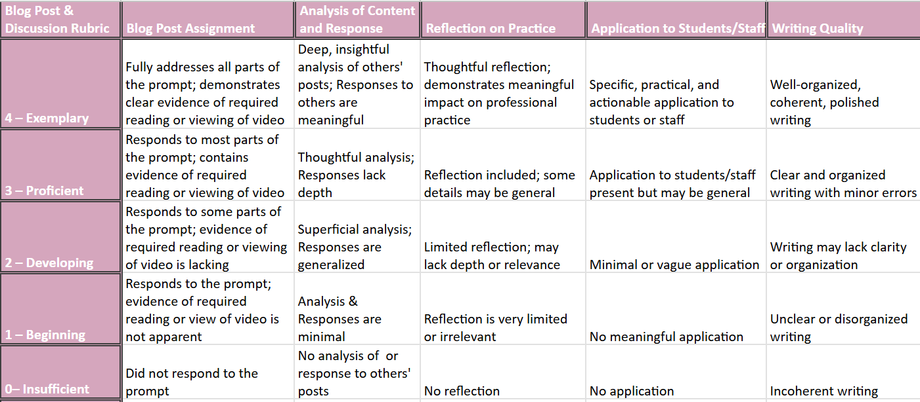

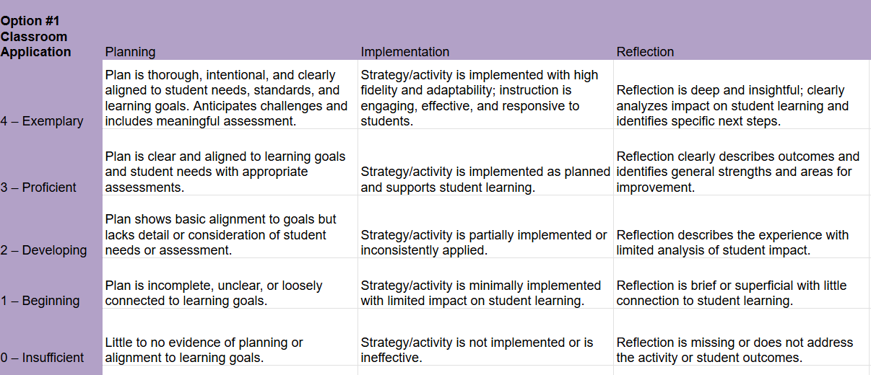

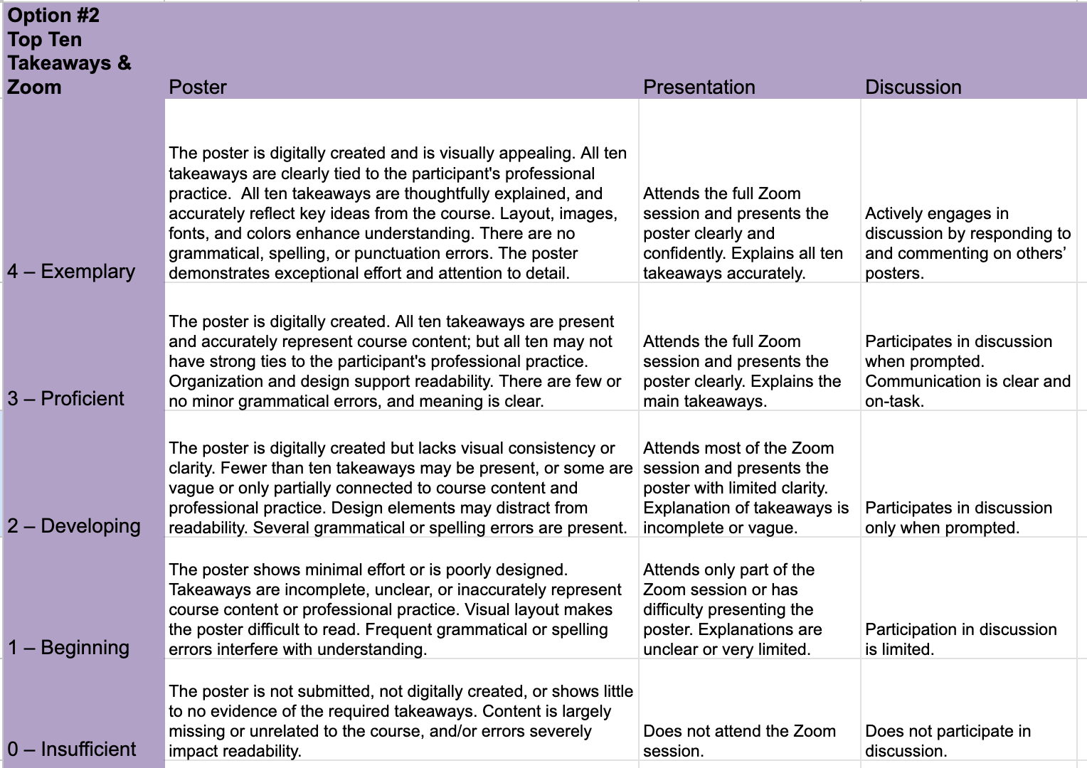

WORKSHOP OUTLINE
Date | Time  (identify all break times) | Topic  (Provide details regarding methodology for presentation of each topic.) | Instructors
Self-Paced Course
 | 2.25 hours | Read Chapters 1-2
 |  | Complete Quiz 1
 |  | Respond to Blog Post 1
 | 0.5 hour | View Video 1
 |  | Respond to Blog Post 2
 | 2.25 hours | Read Chapters 3-4
 |  | Complete Quiz 2
 |  | Respond to Blog Post 3
 | 0.5 hour | View Video 2
 |  | Respond to Blog Post 4
 | 2.25 hours | Read Chapters 5-6
 |  | Complete Quiz 3
 |  | Respond to Blog Post 5
 | 0.5 hour | View Video 3
 |  | Respond to Blog Post 6
 | 2.25 hours | Read Chapters 7-8
 |  | Complete Quiz 4
 |  | Respond to Blog Post 7
 | 0.5 hour | View Video 4
 |  | Respond to Blog Post 8
 | 2.25 hours | Read Chapters 9-10
 |  | Complete Quiz 5
 |  | Respond to Blog Post 9
 | 1.75 hours | Capstone Project
Total Time (excluding breaks) | 15 | Total workshop time must include a minimum of 15 contact hours for each hour of college credit.

Complete one vita for each instructor.
INSTRUCTOR VITA
(complete for each instructor listed on syllabus)
Personal Data
Name | Lindsey Brewer
Address |  | 37386 208th St. |  |  |  |  |  |  |  |  | City / State / Zip |  |  |  | Wessington SD 57350
Home Phone |  |  |  |  |  |  |  |  |  |  | Work Phone
Preferred Email Address |  |  |  |  |  | lindsey.brewer@k12.sd.us |  |  |  |  | Vita Date | 8/10/21
Professional Training
Master Degree (field) |  |  |  |  | Curriculum & Instruction |  | Institution |  |  | Black Hills State University |  |  |  |  |  |  | Graduation Date |  |  | Dec. 2007
Hours Beyond Master’s Degree (The number of hours completed beyond the Master’s Degree must be included.)
School |  |  |  |  |  |  |  |  | Year credit hours were earned. |  |  |  |  |  |  |  |  |  | # of hours
USD |  |  |  |  |  |  |  |  | 2014 |  |  |  |  |  |  |  |  |  | 3
National Board Certification from the National Board
of Professional Teaching Standards |  |  |  |  |  |  |  |  | 2012
Total # of hours: |  |  |  |  |  |  |  |  |  |  |  |  |  |  |  |  |  |  | 3 + NBCertification
Additional Advanced Degree
University |  |  |  |  |  |  |  |  |  |  |  |  |  | Date
Degree |  |  |  |  |  |  |  |  |  |  |  |  |  | Field
Teaching Experience
Position—School / Institution Name |  |  |  |  |  |  |  |  |  |  |  |  | City, State |  |  |  |  | Date (ie: 1980 - 1995)
Adjunct Professor of Mathematics, Dakota State University |  |  |  |  |  |  |  |  |  |  |  |  | Madison, SD |  |  |  |  | 2012-present
Mathematics teacher, Huron High School |  |  |  |  |  |  |  |  |  |  |  |  | Huron, SD |  |  |  |  | 2005-present
Mathematics teacher, DIAL Virtual High School, CORE Educational Cooperative |  |  |  |  |  |  |  |  |  |  |  |  | Platte, SD |  |  |  |  | 2012-present
Mathematics teacher, Howard High School |  |  |  |  |  |  |  |  |  |  |  |  | Howard, SD |  |  |  |  | 2004-2005
Other professional experiences
Received the Presidential Award for Excellence in Mathematics Teaching from the National Science Foundation 2014
Instructional Coach for the Huron School District 2014- 2020
Presented at national education conferences in Boston (2015), San Francisco (2016), San Antonio (2017), and San Diego (2019)
Professional organizations (Write out all acronyms.)
National Council of Teacher of Mathematics

INSTRUCTOR VITA
(complete for each instructor listed on syllabus)
Personal Data
Name | Lori Keleher
Address |  | 39606 US Highway 14 |  |  |  |  |  |  |  |  | City / State / Zip |  |  |  | Huron SD 57350
Home Phone |  |  |  |  |  |  |  |  |  |  | Work Phone
Preferred Email Address |  |  |  |  |  | lori.keleher@k12.sd.us |  |  |  |  | Vita Date | 8/10/21
Professional Training
Master Degree (field) |  |  |  |  |  |  | Institution |  |  |  |  |  |  |  |  |  | Graduation Date
Hours Beyond Master’s Degree (The number of hours completed beyond the Master’s Degree must be included.)
School |  |  |  |  |  |  |  |  | Year credit hours were earned. |  |  |  |  |  |  |  |  |  | # of hours
Waldorf University.  towards an M.Ed. in Social-Emotional Learning |  |  |  |  |  |  |  |  | 2024-2026 |  |  |  |  |  |  |  |  |  | 21
Total # of hours:
Additional Advanced Degree
University |  |  |  |  |  |  |  |  |  |  |  |  |  | Date
Degree |  |  |  |  |  |  |  |  |  |  |  |  |  | Field
Teaching Experience
Position—School / Institution Name |  |  |  |  |  |  |  |  |  |  |  |  | City, State |  |  |  |  | Date (ie: 1980 - 1995)
HS & MS Science teacher, MS Language Arts teacher – Imagine Learning |  |  |  |  |  |  |  |  |  |  |  |  | Phoenix, AZ |  |  |  |  | 2020-2023
Mathematics teacher, Huron High School |  |  |  |  |  |  |  |  |  |  |  |  | Huron, SD |  |  |  |  | 2009-2022
Science teacher, DIAL Virtual High School of the CORE Educational Cooperative |  |  |  |  |  |  |  |  |  |  |  |  | Platte, SD |  |  |  |  | 2003-present
Mathematics teacher, Wolsey-Wessington School |  |  |  |  |  |  |  |  |  |  |  |  | Wolsey, SD |  |  |  |  | 1998-2008, 2022-present
Other professional experiences
Recipient of the Presidential Award for Excellence in Mathematics Teaching from the National Science Foundation, 2009
Instructional Coach for the Huron School District 2010-2020
National Board Certified Teacher as determined by the National Board of Professional Teaching Standards, 2003, re-certified in 2013
Professional organizations (Write out all acronyms.)
National Council of Teachers of Mathematics, Published in the NCTM Journal Teaching Mathematics
Presented at NCTM conferences in Boston (2015), San Francisco (2016), San Antonio (2017), and San Diego (2019)

